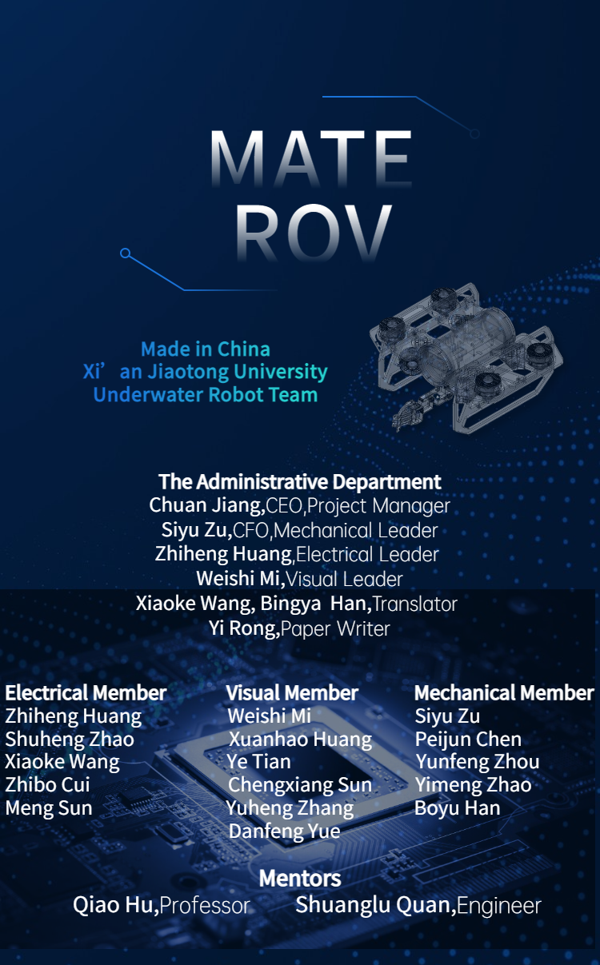

Catalog

**Abstract 1**

**Product Introduction 1**

Product requirement analysis 1

Target market 2

Market prospective analysis 2

Product function introduction 3

**Overall design scheme 4**

Control Scheme 4

Visual scheme 4

**Project Management 5**

Team organization structure 5

**Detailed design scheme 6**

Design Rationale 6

Mechanical structure 7

Electronics 8

Software 10

Production and purchase 13

SID 13

**Mission specifics 13**

Robotic Arm 13

Binocular Camera 14

TASK1 14

TASK2 14

**Team Analysis 15**

Competitiveness and Advantage 15

Challenges 15

Troubleshooting 15

Feelings and gains 16

**Safety 17**

Company Safety Measures 17

ROV safety 17

**Finances 18**

**Acknowledgments 18**

**References 18**

**Appendices 19**

Proposed Budget 19

Cost Projection 19

**Operation and Construction Safety Checklist 19**

**Electronics Troubleshooting Checklist 19**

# Abstract

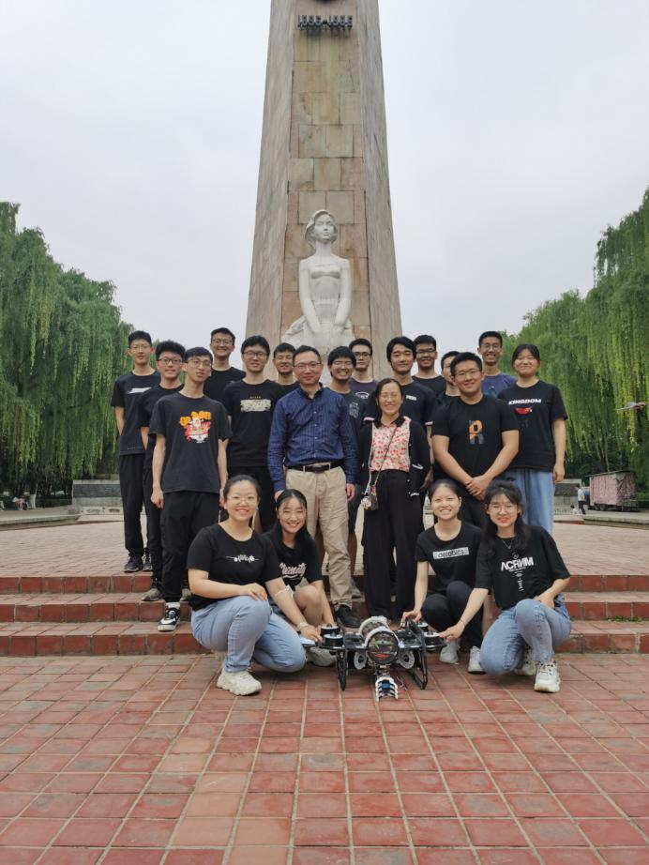Designed as an open-frame ROV, it is equipped with replaceable claws, dual arms and a pressure cabin that has been simulated and tested. The onshore control box is connected to the ROV via a zero buoyancy cable with a stress relief device and transmits power and control information simultaneously using carrier modulation technology. The main control software is decoupled and implemented based on real-time operating system. Data gloves act as an optional control mode of the mechanical arm. Both monocular and binocular cameras are used to support the visual processing capability of the robot. Minimum matrix approximation, subsection weighting, color analysis and machine learning algorithms are used to achieve panoramic image acquisition, automatic docking and aquatic monitoring.

# Product Introduction

## Product requirement analysis

When it comes to ranches, we will think of the pastures in which cattle and sheep are raised on land. Marine ranches tend to transfer this mode to underwater, that is, to achieve aquaculture farming and animal husbandry. This model has high economic benefits, good quality of aquatic products, and reflects the concept of sustainable development. It does not exhaust fish, but also pays attention to the protection of ecological environment while using marine fishery resources. Moreover, the degree of modernization is high, and a variety of intelligent management modes are adopted. The robot we make is an important part of the marine ranch, which can promote the modernization of the management of marine ranch.

At present, the research on the construction of marine ranching in China mainly focuses on the following aspects : the location of marine ranching, the performance of reef and algal reef materials, the structure selection of reef and algal reef, the layout design of reef and algal reef combination, the ecological effect of marine ranching, and the construction of marine ranching monitoring system. But there are also many shortcomings in construction, such as :

Lack of scientific planning. Due to various factors, the early investigation and evaluation of the construction of marine ranching is not standardized, and the scientific construction plan is weak, which will make the construction of marine ranching fail to achieve the desired effect. Especially in the construction of artificial reefs, if the site selection is improper, or the reef type and layout are unreasonable, it can not give full play to the ecological restoration and optimization of artificial reefs, even the problems of reef burial and subsidence, reduce the function of resource conservation.

Monitoring and evaluation are difficult. The effect monitoring and evaluation is an important basis for the operation, maintenance and supervision of marine ranches, but there are still great difficulties in carrying out this work. One is the lack of effective monitoring means. Second, the lack of monitoring funds and professional monitoring team. Therefore, more manpower and material resources will be invested in the inspection of some reefs and reefs in the seabed of marine ranching, the observation and investigation of fish ecology in the marine ranching area.

Lack of appropriate fishing methods. Seabeds of marine ranch are covered with reefs and algae reefs, which are not suitable for trawling of marine products and cause secondary damage to the seabed environment. For slow-moving aquatic products such as sea cucumber and scallop, artificial fishing is mostly adopted at this stage. In addition to low efficiency, the way to the health of the diver itself caused some hidden dangers, and winter temperature is not suitable for divers into the water. This forms certain resistance to the economic benefits of marine ranching.

Based on the above reasons, our team chose to use underwater robots instead of artificial mode, designed a ROV ( remote control unmanned submersible ), with mechanical arm and binocular vision camera, provides a new scheme for the construction of marine ranching. Using this robot can save manpower and material resources, liberate from the traditional human fishing, and make the aquaculture fishing move towards mechanization. At the same time, the characteristics of multi-visual function integration greatly improve the management efficiency of marine ranches, which is in line with the characteristics of modern marine ranches and makes the management of marine ranches more intelligent.

## Target market

It is mentioned in the product analysis that our robots are used in the field of marine ranches, belonging to industrial robots and facing the market demand of underwater robots. According to public data, the market scale of civil underwater vehicles in China will reach 580.65 billion yuan by 2020, of which the market scale of resource exploration underwater vehicles is 24.15 billion yuan, accounting for 41.59 %. The market size of safety monitoring underwater vehicle is 19.43 billion yuan, accounting for 33.45 % ; the search and rescue robot market will reach 6.83 billion yuan, with a market share of 11.75 %.

Compared with the mature unmanned aerial vehicle market, the underwater vehicle industry in China is still in its infancy, and the consumption level of underwater vehicle technology and functions are relatively simple. With the continuous improvement of underwater robot technology and performance, the function will be more and more perfect, can replace human underwater work in more fields.

However, due to the different working environment, the R & D technology requirements of underwater vehicles are higher. At this stage, there are fewer enterprises in China, fewer enterprises with independent R & D capabilities and strong strength, and more capital injections are urgently needed in the industry. Our country has a long coastline and more underwater work opportunities, but the risk of underwater work is high, especially in the deep sea area. With the continuous development of underwater robot technology and the continuous improvement of its function, the feasibility of replacing human underwater operation is higher and higher, the market demand will continue to increase, and the future development prospect is broad.

## Market prospective analysis

Underwater robot industry is mainly concentrated in North America, Europe, China, Japan and other countries and regions. At present, China is the largest production area. From the consumer side, China 's underwater vehicle industry accounted for 25.07 per cent of global sales in 2018. China 's huge market demand and growth potential attracted almost all international giants to carry out related operations in China. According to the ' 2018-2023 China underwater vehicle market survey and industry analysis report ' released by the New World Industry Research Center, it is expected that the market size of China ' s underwater vehicles will reach 58.065 billion yuan by 2020, of which the market size of resource exploration underwater vehicles is 2.415 billion yuan, accounting for 41.59 %. The market of safety monitoring underwater vehicles is 19.43 billion yuan, accounting for 33.45 % ; the search and rescue robot market will be 6.83 billion yuan, accounting for 11.75 %. The development prospect of underwater robots in China is broad.

In terms of economic benefits, compared with the United States and Japan, the industrialization of underwater vehicles in China has made slow progress on a global scale, but has accelerated in recent years. Thus, the field of underwater machinery itself has a larger development prospects and progress space. It can be seen from the chart that the application fields of underwater robots in the world are mainly logistics, military and other fields. There are few underwater robots used in marine ranching and there is a huge potential excavation space.

## Product function introduction

**Overall scheme of robot mechanical design**

According to the characteristics of marine ranching, the corresponding structure was designed.

The overall design of the robot adopts open frame structure, using HDPE polymer polyethylene material ;

The pressure warehouse adopts cylindrical structure, easy disassembly and assembly, large internal space, good waterproof effect ;

Through the analysis of the strength of the pressure bin, we finally determine the use of acrylic as pressure bin material, compressive strength is far to meet the requirements ;

Layout of propellers : the our robot has eight propellers, the outer four control floating and diving, the inner four control directions, to achieve six degrees of freedom of the robot ;

Mechanical arm : Single mechanical arm can complete the corresponding engineering grasping operation.

**Introduction of Robot Control Scheme**

In terms of control, we use remote control to control the manipulator and robot motion. In addition, in the organization of the overall control logic, we divide the logic framework into three layers : BSP layer, DRIVER layer and TASK layer, which are applied to the underlying architecture configuration, the original receiving data analysis and task logic execution. In terms of hardware, we designed control schemes for chassis motion drive and gravity center self-regulation, we used the PID design.

**Introduction of robot visual function**

The visual part of our robot is a workflow of capturing images with cameras, processing image matrices with raspberry pie, and completing visual tasks. We can achieve multiple functions such as acquiring deep-sea panoramas, automatically entering docking stations, monitoring fish health, monitoring dead fish, and measuring fish length to analyze age structures.

Deep sea panorama is obtained by image stitching. On the basis of the conventional image stitching process, the minimum rectangle approach to the target area and the clipping method, and the weighting method of the piecewise weight function with the advantages of both the square function and the power function, respectively, solve the two major problems of clipping multiple regions and eliminating the obvious discontinuity of overlapping parts.

Automatic access to the docking station by tracing. The conventional tracking idea is to take multiple points in the image matrix to represent the relative position of the ROV and the target path. We apply this idea to the problem of entering the docking station.

Monitoring fish health by color recognition. With the support of relevant research, we select the color of fish fin as one of the health indicators, and select the appropriate range for H, S and V with the extremely rich advantage of the color picker. The three values are adjusted with the help of the trajectory bar to realize the color recognition.

Using YOLOv5 to detect dead fish and binocular distance to measure fish length. On the basis of well-configured environment, we use a lot of data to train to monitor dead fish ; at the same time, we use the parallax sounding of binocular cameras to obtain the distance between the camera and the fish, and then measure the fish length, and finally realize the statistics of fish length to evaluate the age structure of pasture fish.

# Overall design scheme

## Control Scheme

**Overall design principle:**

The electronic control module takes STM32 single chip microcomputer as the overall control basic, and carries out the overall bottom code common layer configuration through keil5 software, so as to complete the signal transmission and reception functions of remote controller, propeller and gyroscope. Based on the underlying code, the basic motion and task functions of the robot are divided into four detailed design schemes: chassis travel, attitude control, depth detection and manipulator control. In the actual line layout, the power carrier and step-down module are used to connect the main control modules, adjust the voltage, connect the serial communication, and transmit the signal to the propeller and manipulator, so as to realize various functional requirements of the robot and complete the corresponding task objectives.

**Scheme model:**

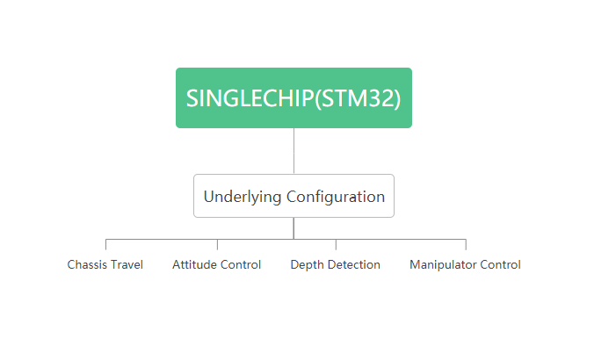

*Figure1 Overall design principle*

**Control logic:**

Taking STM32 single chip microcomputer as the reference module, the communication is realized by connecting each serial port through the control of the bottom layer, so as to receive and transmit the control signal to the module. In the interior of the robot, the depth of the robot and the deflection direction of the attitude are measured by the gyroscope, and the attitude and depth data are transmitted to the single chip microcomputer for PID calculation, and the PWM signal is sent to the propeller to realize the self-regulation of the robot's attitude. Taking the remote controller as the main external control hardware, by changing the three different gears of the remote controller, the speed control in the X and Y directions of the chassis and the attitude speed adjustment in the three axes of yaw, pitch and roll in the attitude adjustment are realized respectively, and the rotation, clamping and other functions of the manipulator are completed, so as to realize the clamping ability of the object. At the same time, the automatic motion control function module is configured to place the remote control in the third gear. The robot will solve and judge the target task position according to the position and distance information transmitted by the raspberry pie, and intelligently regulate the speed direction to the specified position.

## Visual scheme

The visual part uses raspberry pie as the code running platform, and uses different programs to call different ports and devices, execute different algorithms and complete different tasks.

**Project Management**

## Team organization structure

The team consists of four separate departments, namely mechanical, electronic, visual and administrative departments. Each department is headed by a separate department head, and the CEO communicates directly with the department head for planning. The mutual communication and cooperation between the leaders of various departments is conducive to the mutual cooperation, coordination and communication between various departments, and improve work efficiency. We share a Git-hub knowledge base among department members, and each member regularly updates his/her work in the knowledge base, so that the department head can keep track of the work progress and solve problems in time.

**Electric control**

Overall scheme design —— Zhiheng Huang

Bottom code writing —— Zhiheng Huang

Chassis propulsion —— Shu-heng Zhao

Attitude adjustment —— Xiaoke Wang

Manipulator control —— Zhibo Cui

Depth detection —— Meng Sun

**Visual**

Overall program design —— Weishi Mi

Red Rope Trail —— Xuanhao Huang

Automatic inbound and point recognition

——Ye Tian

Measuring fish length ——Chengxiang Sun

Raspberry PI control and network management

——Danfeng Yue

Identify dead fish ——Yuheng Zhang

Mechanics

Overall program design ——Siyu Zu

Mechanical claw design and manufacturing robot assembly, buoyancy optimization

—— Peijun Chen

Robot design and fabrication, assembly, wiring

——Yunfeng Zhou

Shore control box design ——Yimeng Zhao

set construction —— Boyu Han

**The administrative department**

CEO —— Chuan Jiang

Manager of electronic control Department

—— Zhiheng Huang

Visual department Manager —— Weishi Mi

Manager of mechanical Department ——Siyu Zu

The CFO —— Siyu Zu

Translation —— Xiaoke Wang, Bingya Han

Paper Writer —— Yi Rong

**Timing and scheduling**

*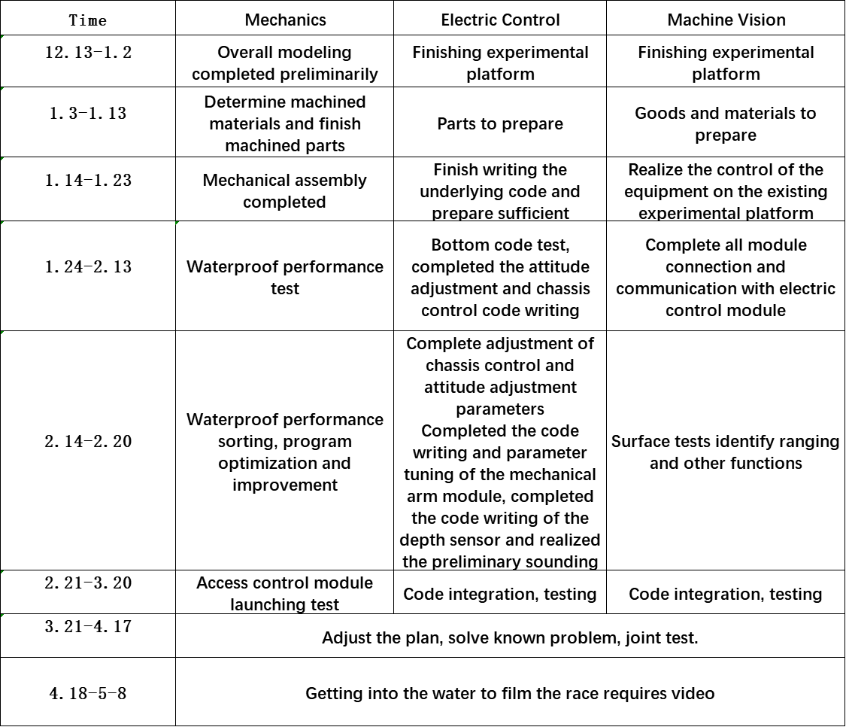Table1 Timing and scheduling*

# Detailed design scheme

## Design Rationale

Designing stage, company members held a two-hour discussion right after a meeting aiming to make sure that every participant is clear about the mission to be done. On the discussion, we exchanged ideas and confirmed the overall construction of our ROV mainly based on several underwater vehicles we produced. One vital aspect of the discussion is to determine which parts of the previous robots(figure) are to be kept and which are to be replaced or developed. Up first, it’s widely agreed that the whole frame needs to be redesigned. Last robot was an AUV and doesn’t have a gripper, while the construction is just not appropriate for the tasks. So we remodeled a frame and discussed about the assemble position of the gripper according to the range of motion required to finish the mission. Second, on the old AUV, with a design of three bodies on a horizontal plane provided enough room for electronics to be housed but also brought trouble to fitting and checking. After considering, we decided to adapt one-body-design. Despite the fact that a circular column body is more likely to have room wasted, a cuboid body will have problem with waterproofing, however. It’s obvious that waterproof is more important, so we used a ROVMAKER column body finally. Beside these, the main equipment include a binocular camera and a monocular camera are separately installed in the front of the main body and by the body outside it, which is only used to provide a view on gripper for the pilot. And an alternative battery is also available to support the vehicle for a while in case of emergency. The gripper is designed to have two degrees of freedom, which is considered to be sufficient.

## Mechanical structure

**Frame**

The frame consists of a mechanical arm retainer, two base stabilizers, four horizontal stabilizers, two sides, four main cabin supports, and two anti-collision stents. The main part of the frame were redesigned, while there was no built-in battery in the vehicle and the battery cabin’s position was spared for the mechanical arm. The frame is manufactured using 2D routing machines from 10 mm thick high-density polyethylene “HDPE”, this material was chosen due to its cheapness, high density-to-strength ratio and high strength under nominal stresses.

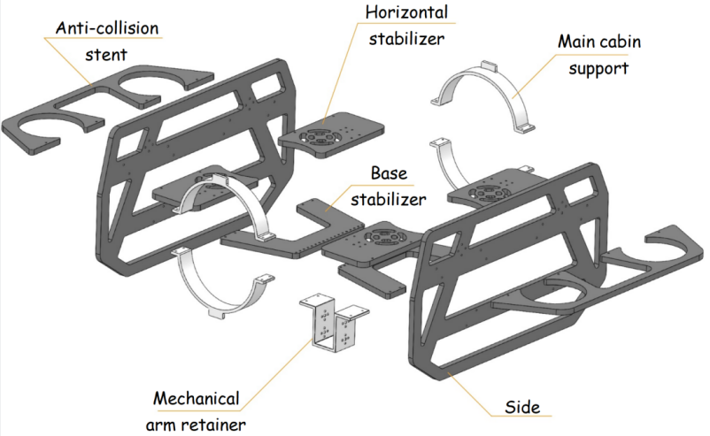

*Figure2 Exploded View of the Frame*

**Thruster**

Our vehicle is equipped with eight T200 Bule Robotics thrusters. These powerful, compact, and efficient thrusters offer the vehicle a remarkable improvement. We used four heaving thrusters - one at each corner - and four surging thrusters that are mounter at 45° around the main cabin at each corner.



*Figure3 T200 Thruster Figure4 Thruster Layout*

*with Protective Guards*

This layout of thrusters can maximize stability and obtain a stable vector drive, allowing all thrusters to contribute to the total propulsion in all cardinal directions. Together with the slots on the side can also reduce the flow interference.

**Enclosures & Sealing:**

The vehicle uses one main cabin to contain all control subsystems in a cylindrical-shaped enclosure, which is made of Poly(methyl Methacrylate)(PMMA) acrylic, which is transparent, allowing us to view the interior clearly. The main cabin is capped with two aluminum flanges. Inside the main cabin equipped a binocular camera on one side and cables thread through the end cap on the other.

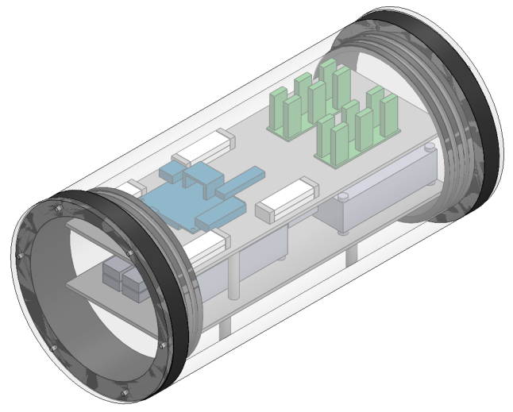

*Figure5 Main Cabin*

It is required that the vehicle pulls or plugs the props during the competition, therefore a reliable mechanical arm that provides a high gripping force can meet the requirement. To ensure the mechanical arm have enough DOF and strength, we equipped it with three waterproof steering gears, allowing it to swing up and down, spin, and grab. In order to grab different sizes of PVC pipes tightly with only one gripper, the mechanical arm is equipped with an asymmetric structure. While grabbing the pipes, the teeth of the gripper can cross the others until the pipe is held tightly.

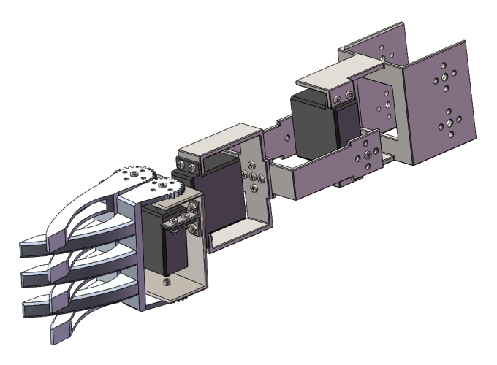

Figure6 Mechanical Arm

The vehicle will face fifty thousand Pa in the five meters deep, which set a strict requirement to the waterproofness of the main cabin. Water Sealing mechanisms are done using three main sealing methodologies: compressed toric joints “O-rings”, Marine Epoxy, and mechanical seals. The main cabin is sealed with compressed O-rings, such that all cables run through penetrators which in turn are sealed with marine epoxy. Penetrators were used instead of cable glands as they provide a better water seal.

## Electronics

Underlying code common layer:

The main design ideas of the public bottom layer are:

① Separate the main tasks of the robot and provide an independent running environment for each task as much as possible, so that the main control program is easy to realize multi person cooperation;

② Unify variable interface, reduce debugging difficulty and improve program maintainability;

③ The BSP layer is used to divide the hardware related code of the main control board and other electronic control codes, and the driver layer is used to divide the specific electronic control hardware code and abstract task code, so as to realize the decoupling based on the hardware level and facilitate the program management;

④ Standardize the call management of MCU peripherals and avoid conflicts caused by multi person cooperation.

The BSP layer mainly completes the following contents:

① Complete the initialization configuration of each MCU peripheral;

② Re encapsulate the related functions and handles in Hal library for the driver layer to call;

③ Quickly handle hardware interrupts and provide callback processing mechanism support for hardware interrupts;

④ With the help of FreeRTOS operating system, the basic framework of multitask scheduling mechanism and interrupt delay processing is constructed.

Through the design of the common layer of the underlying code, the control code compilation of each system module can be unified, the compilation difficulty and complexity of each module can be greatly simplified, and the optimization and adjustment of each module and the optimization cooperation between modules can be simplified. The task layer and driver layer are used to compile the corresponding task modules, which provides an independent debugging space for the task compilation of different modules, which is convenient for multiple people to compile together, It is conducive to the maintenance, optimization and debugging management of the program, and avoids the conflict caused by multi person cooperation on the basis of fully realizing the cooperation of multiple modules.

**Chassis travel and attitude control**

Module composition:

Motor propeller, gyroscope, STM32 single chip microcomputer, remote control.

Algorithm model:

The chassis travel and attitude control takes the PID algorithm solution as the main logic of the program coding, defines and sets the eight thrusters of the robot, receives the external control signal from the remote controller, the robot attitude signal from the robot's internal gyroscope and the depth signal calculated by the depth detection module based on the bottom common layer, and uses the PID solution to convert it into the robot's x, Y direction, roll angle, yaw angle The speed output of pitch angle decomposes the speed vector of different motor thrusters between the chassis travel and attitude control modules, and transmits the output signal (PWM wave) to the corresponding motor thrusters to complete the robot travel mode required by the task.

At the same time, the intelligent travel mode of the robot is configured to receive the distance, position and other information from the raspberry pie, calculate the speed of each direction and axis required by the task target through the PID algorithm, and decompose it to the corresponding motor propeller, and control each propeller with PWM wave to carry out self-control according to the specified requirements.

Block diagram:

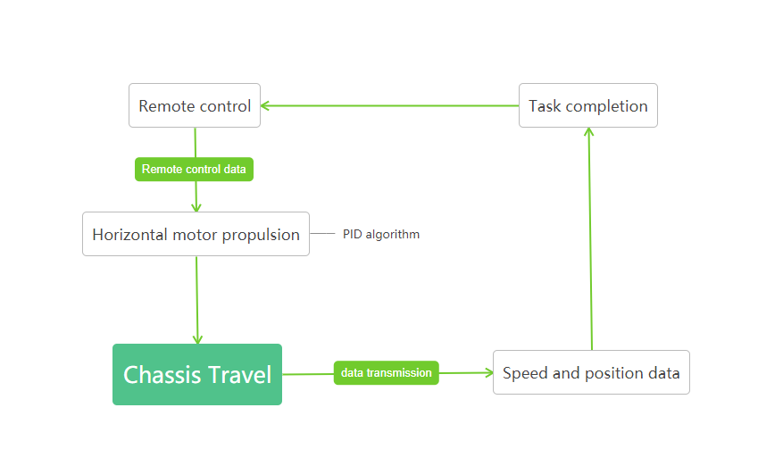*Figure7 Chassis travel*

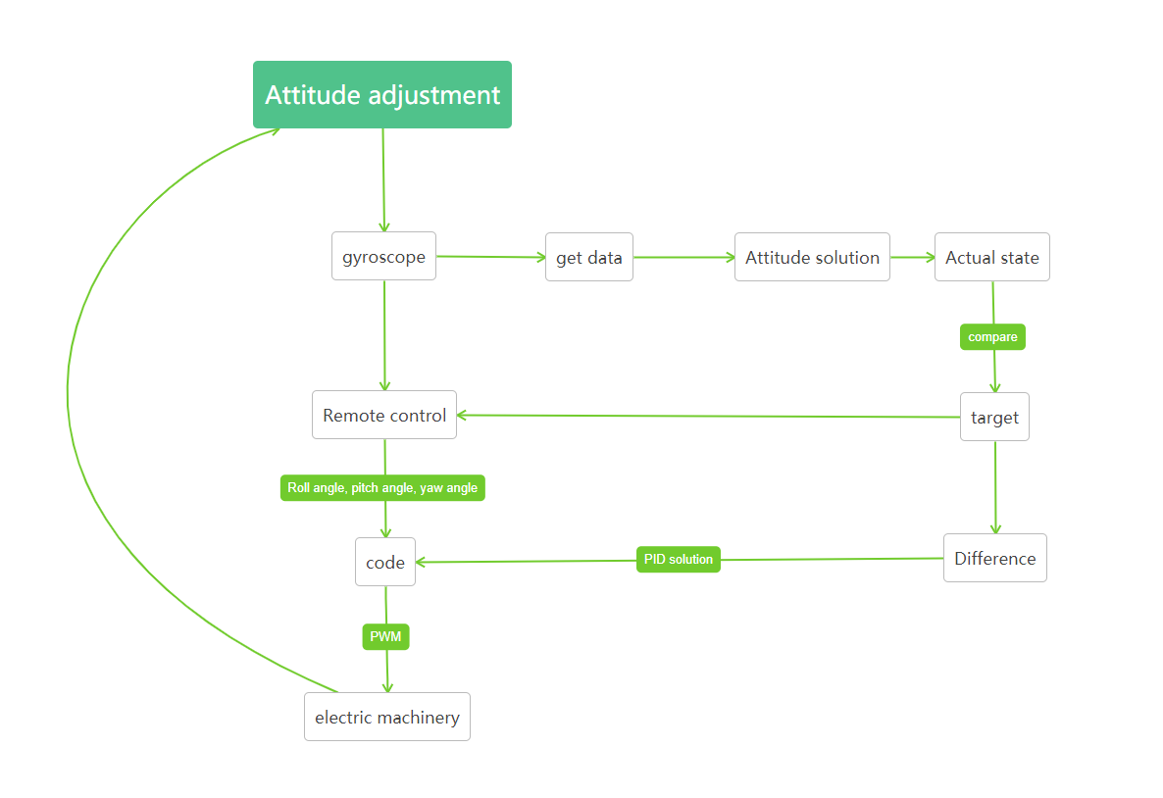

*Figure8 Attitude control*

**Manipulator control**

**Module composition**

Manipulator, remote controller, steering gear, STM32 single chip microcomputer.

**Algorithm model**

The manipulator control module takes the remote control as the main operation means. In the code layer, through the way of PID solution, the serial port communication of the bottom common layer is used to receive the rocker data from the remote control, so as to complete the object clamping task of the manipulator. In the code layer, in order to avoid conflict with chassis travel and attitude control, the remote controller is compiled with the paddle detection algorithm, which is compiled through three task layers with different gears to allocate different function module control space.

The external control mode of the manipulator uses the remote controller to adjust the paddle and detect the data of the manipulator. According to the PID algorithm, the paddle signal is incrementally added and solved, and the corresponding solution data is transmitted to the steering gear module in the form of PWM signal. At the same time, the correctness of the data is judged in the process of signal transmission to ensure the accuracy of the rotation and clamping of the mechanical arm, and the data boundary value is set to prevent the data from exceeding the limit, protect the safety of the steering gear and complete the corresponding tasks.

**Block diagram**

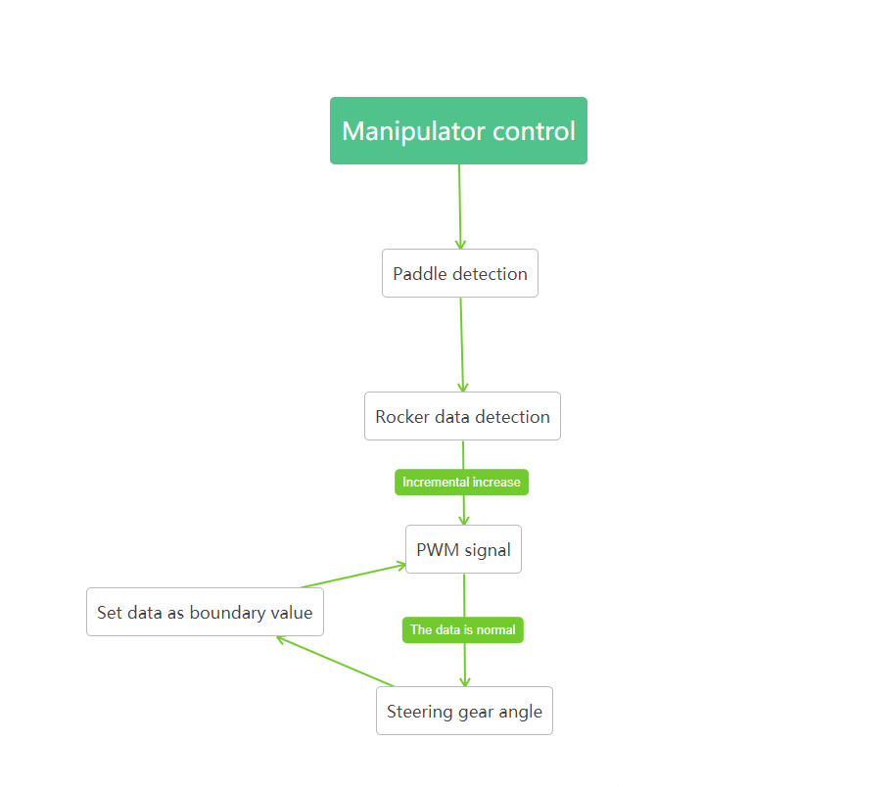

*Figure9 Manipulator control*

**Depth detection**

**Module composition**

Gyroscope, STM32 single chip microcomputer, pressure sensor.

**Algorithm model**

The depth detection module focuses on the detection of pressure and temperature. Through the internal perception of the robot by gyroscope and pressure sensor, the specific depth conditions of the robot are judged, and the depth data is transmitted to STM32 single chip microcomputer in the form of signal and displayed in the corresponding external control and receiver. Through the code communication and serial port connection between each module realized by the bottom code common layer, the pressure and temperature are compared according to the prom calibration parameters and the specific parameters of the robot, the corresponding relationship coefficient data of the depth of the robot is obtained, and it is transmitted to the STM32 single chip microcomputer for depth data calculation, the specific depth data is obtained and the depth error is calibrated.

After the error calibration, the exact data will be transmitted, the depth will be converted and displayed in the external control and receiving module, and the depth of the robot will be adjusted by combining the robot's self-control with the external remote control device, so as to push the robot to the correct depth position.

**Block diagram**

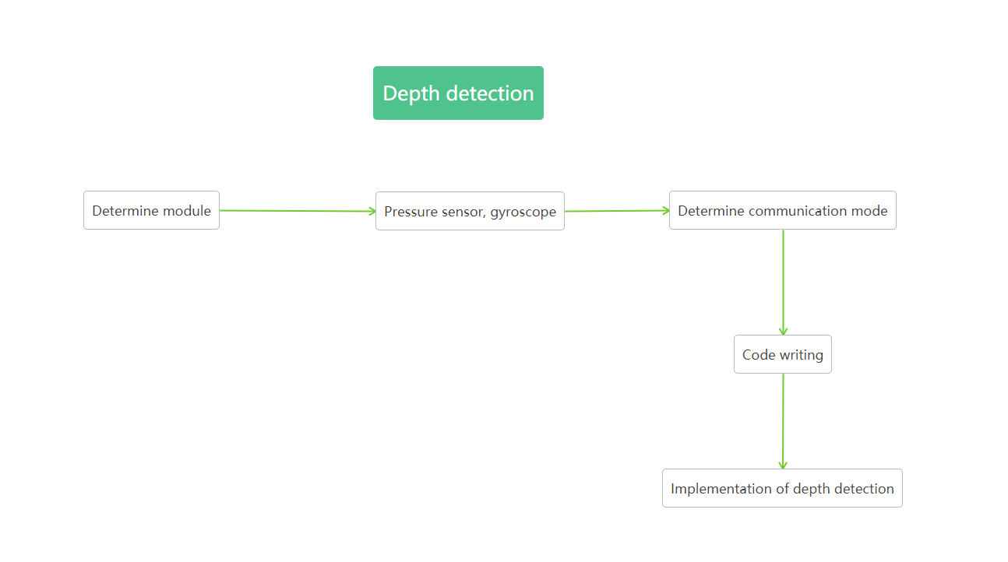

*Figure10 Depth detection*

## Software

**Recognize “morts”**

Task Interpretation -- identifying live and dead fish through in-depth learning

Task description:

Highlight the dead fish with a red box. When their program successfully distinguishes between live and dead fish, the company will get 10 points. The definition of successfully distinguishing live fish from dead fish is to highlight all dead fish in the downloaded video with a red box on the screen —— Original description

Solution:Use code from GitHub - ultralytics / yolov5.YOLOv5 is a family of object detection architectures and models pretrained on the COCO dataset, and represents [Ultralytics](https://ultralytics.com/) open-source research into future vision AI methods, incorporating lessons learned and best practices evolved over thousands of hours of research and development. Use roboflow to prepare, train, and control datasets using roboflow Model.Use yolov5 algorithm to realize the recognition of dead fish, collect the photos of model fish, create a data set, train the neural network after extracting the features of the picture convolution layer, so that the dead fish at the bottom can be framed.

**Measure Fish Length**

In order to complete the task, we choose binocular stereo vision measuring system to get the length of the fish. Binocular ranging is divided into 4 steps: camera calibration - binocular correction - binocular matching - calculation of depth information.

**Camera calibration**

The camera due to the characteristics of the optical lens so that the imaging has radial distortion, can be determined by the three parameters k1, k2, k3; due to the error in assembly, the sensor and the optical lens is not completely parallel, so there is tangential distortion in the imaging, can be determined by the two parameters p1, p2. The calibration of a single camera is mainly to calculate the internal reference of the camera (focal length f and the imaging origin cx, cy, five distortion parameters (generally only need to calculate k1, k2, p1, p2, for fisheye lenses and other radial distortion is particularly large to calculate k3)) and external parameters (the world coordinates of the calibration). Binocular camera calibration not only needs to derive the internal parameters of each camera, but also needs to measure the relative position between the two cameras (that is, the rotation matrix R of the right camera relative to the left camera, the translation vectort).

**Calibration (by MATLAB or openCV)**

Binocular correction: Binocular calibration is based on the monocular internal reference data (focal length, imaging origin, distortion coefficient) and binocular relative position relationship (rotation matrix and translation vector) obtained after the camera calibration, respectively, the left and right views are eliminated distortion and line alignment, so that the imaging origin coordinates of the left and right views are consistent, the optical axis of the two cameras is parallel, the left and right imaging planes are coplanar, and the polar lines are aligned. In this way, any point on one image and its corresponding point on another image must have the same line number, and only one-dimensional search on that line can match the corresponding point.

Binocular matching: The role of binocular matching is to match the corresponding image points of the same scene on the left and right views, and the purpose of this is to get a parallax map. Binocular matching is widely regarded as the most difficult and critical problem in stereo vision. Obtaining parallax data, the depth information can be easily calculated through the formula in the above principle.

Ranging:

For each single-purpose image through the contour to calculate its shape center, and then through the binocular camera parallax map to obtain its shape center to the binocular camera distance, the distance is approximated to the distance of the fish to the robot to be measured, and then find out the maximum external circle of the image outline, and double the radius of the object to be measured in the image of the pixel length. Thus, according to the calibrated focalLength, the measured distance (KNOWN_DISTANCE) and the length of the pixels occupied by the object to be measured in the image (markerLength), the length of the fish to be measured can be calculated:

Length=(markerLength*known_distance)/markerLength

Go to the Resident ROV stop

We chose autonomous driving to implement the function of automatic inbound. The position is calibrated by the red dot in the center of the outermost edge of the stop, the length of the white rod above the center of the red dot is detected, and the distance from the ROV to the red dot of the stop station can be calculated by combining the known length and camera focal length, and then the ROV stop state can be controlled autonomously.

First of all, we convert the pictures taken by the binocular camera from RGB format to HSV format, and in the process of preliminary processing of images, we optimize the imaging effect by mean filtering and denoising and conventional corrosion treatment of HSV format images to eliminate interference. We filtered the target red dot by adjusting the chromaticity bar, selecting the appropriate hue interval, saturation interval and brightness interval, and determining the center x, y coordinates and radius of the red dot by looking for the outline and delineating the smallest circle, and circled the visualization in the original image. In the process of finding the contour, although the original image is processed, the contour interference other than the target outline is still difficult to avoid, so we traverse the contour set, through the radius limit of the minimum contour envelope circle, to select the radius of the reasonable radius and finally achieve the selection of the target outline.

We then convert the original image into a grayscale graph and filter out the white bar section by adjusting the appropriate threshold. With the x-coordinate of the center of the red dot known, we look for all the points with an abscissa of x in the grayscale plot and calculate the number of white dots, thus obtaining the number of white rod pixels above the center of the red dot. Only a column of points with an abscissa of x is selected as the study object, it is difficult to meet the practical requirements of the ROV still measured the reference data under the shooting angle offset, so we enhance its robustness, count the 21 columns of pixels under the x-axis interval of x center and left and right 10 pixels, and take the maximum value of the white pixels of each column as the final white rod length to meet the practical requirements of ROV can still judge the distance when the azimuth offset.

Finally, we calculated the actual distance by "the actual distance is equal to the product of the known length and focal length, the ratio of the measured pixel value", referring to the robot size and the ROV stop size, we determined the distance that the ROV does not touch the stop and completely enters the station, at this distance the electronic control will receive the stop information, and the ROV automatically stops. At the same time as completing the task, we have a plan for the special situation of not detecting the contour and not having the appropriate size contour, which can ensure the normal execution of the task when abnormal situations occur.

**Red Rope Tracing**

To complete this task, we distinguish the red rope by Canny edge detection algorithm and Hough transform and guide the robot forward by feather points of the rope.

After capture the image, we first transform the RGB image to grayscale image and then reduce the noise by Gaussian Blur filter. Considering that the color of the rope is red which is much different from that of background, the edge of the rope is easily to be detected, so we extract the edges by Canny edge detection algorithm, which is the most efficient algorithm. Additionally, we use trackbars to adjust the thresholds in double threshold suppression segment for best edge detection result.

Now we have detected the edge of the rope, but many other objects’ edges are in the image as well, which is what we don’t hope to see. In order to remove those irrelevant edges, we suppress those edges with insufficient red component around them.

After obtain the edges of the rope, we should compute the feature points. We find the straight line in the edges by Hough transform. We transform the (x, y) plain of origin image to (a, b) plain. A point in (x, y) plain matches a line in (a, b) plain. A grid with the most lines pass will be transformed back to a corresponding line in (x, y) plain. We adjust the thresholds such the size of each grid and the minimum length of a line by trackbars as well.

We compute each line’s slope to distinguish horizontal lines and vertical lines. A line has two edges in the both sides, so we can get the feature point by computing the mid-point of the edges. And the feather points can help to lead the way. If there is no horizontal line detected, the robot should go up or down. And if there is no vertical line detected, the robot should go right. The motion state changes when detecting horizontal and vertical lines at the same time, and the next motion state depends on the previous one. The correction of the position of robot is also depends on the feature points. That the feature points is not in the middle of the image means the robot drifted off the course, so we should send corresponding message to correct it.

## Production and purchase

**Robot installation**

First assemble the robot in SolidWorks software, and then purchase and process materials after confirming that there is no problem. Finally, install the whole robot in the laboratory, first assemble the frame, then fix the cabin, and finally install the manipulator.

**purchase**

* Mechanical part

Acrylic cabin

Frame (4 parts in total)

3D printing parts (5 kinds and 17 pieces in total)

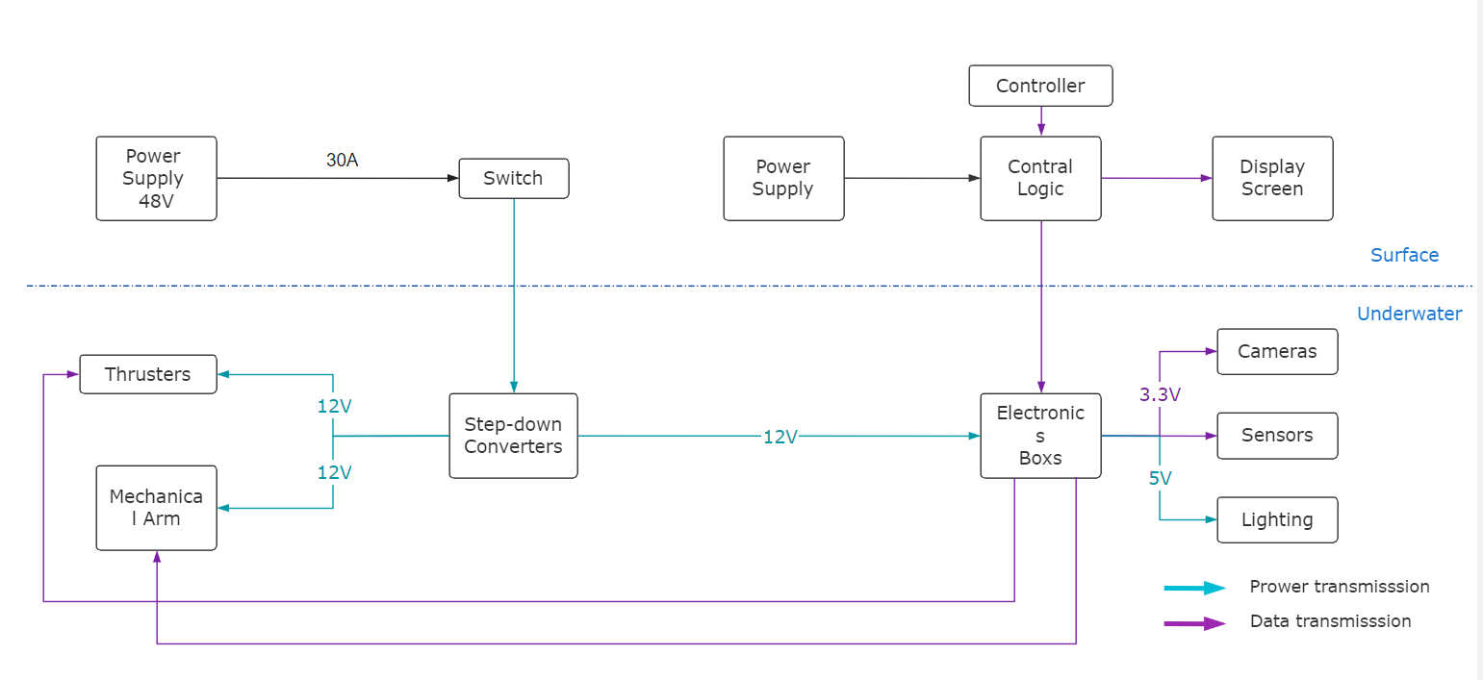Fiberglass board × 2

Screws, studs, locknuts

Waterproof steering gear × 4

Sheet metal workpiece × 8

* Electric control part

propeller

Motor governor

Depth sensor

Power carrier

electric machinery

Cable

Wireless burner

* Visual part

Binocular camera × 3

Fisheye camera

Robot camera

SD card × 3

Monocular camera

## SID

*Figure11 SID*

# 

# Mission specifics

## Robotic Arm

Because the tasks require the robot to grasp objects of various shapes, the team designed a single robotic arm with a mechanical claw. The robotic arm and claw are controlled by the steering gear and they can achieve 180° and 360° rotation, respectively. After testing, the grip of the mechanical claw can be stably controlled, and a variety of shapes of rigid and soft bodies can be grasped.

## Binocular Camera

Due to the need to measure the length of the fish, the team choose to use a binocular camera. Controlled by the Raspberry Pi, it can transmit underwater video in real time, so the computer is able is take pictures, take screenshots, and perform a series of tasks such as object recognition and length measurement.

## TASK1

* 1. Replacing a damaged section of an inter-array power cable

Through remote control, the operator controls robot to dive to the appropriate depth to the Raspberry Pi binocular camera field of view appears in the cable than starts the automatic motion mode to keep the robot at a fixed depth. Our company member controls the robot horizontally through the computer, finds the damaged cable through the video display (brown paint spots are found), makes the robot move to the damaged cable, operates the robotic arm, and the mechanical claw pulls out the pin to release the damaged cable. Switch to remote control mode, control the robot to return to the surface of the water to take the new cable, and then dive, switch the automatic control mode to find the disassembly place, control the mechanical claw to connect the new cable.

* 1. Replacing a damaged buoyancy module on an inter-array cable of a floating offshore wind turbine

The robot locates the damaged cable through a video display and releases the clamp with a mechanical claw. The operator control robot returns to the surface of the water by remote control, gets the buoyancy module and dives back down then moves to the original position, operating the robotic arm fixing fixture.

* 1. Monitor the environment

The robot first uses a mechanical claw to clip the pipe and place it in a designated area, and then performs the task of removing the ghost net, pulling out the pin with the mechanical claw, grabbing the ghost net and moving it back to the surface, and the members help to remove it. Return to the hydrophone and retrieve the hydrophone.

1.4 Piloting into “resident ROV” docking station

The robot into the stop automatically.

## TASK2

2.1 Inspecting an offshore aquaculture fish pen

The operator-operated robot grabbed the patch and dived to the appropriate depth, controlling it to move along the red rope line, and the members observed through the binocular camera on the computer end to count the number of damaged areas. After the movement, the robot returns to the last damage area, and the operator operates the robotic arm to paste the patch.

2.2 Maintaining a healthy environment

After the robot dives to the appropriate depth, it switches to automatic mode, and the members control the robot's movement through the computer, and the image is transmitted back to the computer to identify the dead and live fish. A computer-operated robot catches a dead fish and moves it into a collection tube.

2.3 Measure fish size

The robot dives to collect images of three fish and measures the length of the fish through artificial intelligence to calculate the average.

After the members are informed of the relevant data, they substitute the formula to calculate the biomass.

2.4 Farm seagrass

The operator controls the robot to complete the dive and grab the seagrass bed, and after sending it back to shore, control the mechanical claw to release the original seagrass bed and grab the new seagrass bed and put it back in its original position.

# Team Analysis

## Competitiveness and Advantage

After months of precise design and repeated test,our company eventually accomplished our ROV.To improve its performance,we investigated the previous design of the ROV,and then launched our own project,which is competitive and advantaged.

Firstly, we optimized the overall arrangement of the robot.The cabin is designed as a cylinder to minimize the resistance under the water.Eight propellers,which are designed to control the motions of the robot, are well-organized and placed on the symmetrical parts of the ROV.The design can guarantee the flexibility and comprehensiveness of the motion.

Secondly,the mechanical arm is specially designed to satisfy the requirements.It has five degrees of freedom and the joint is motivated by steering engine,which can make the rotating of the different parts conveniently and precisely.

Besides the large sum of work we have done on the design of the ROV,we also tested the robot for several times,which ensured the correct operation of each systems.During the test,the ROV showed brilliant behavior under the water.The abundant experiment plays a big role in supporting our project and this can be a great advantage in our project.

## Challenges

Our company experienced several challenges during our fabricating of ROV.They brought us troubles while they helped us to improve and make our design more reasonable and efficient.

The first challenge we met was the overall arrangement of our ROV and the concrete design of mechanical arm.We took fairly long time to investigate various kinds of ROV made by other companies and compare their advantages and disadvantages.Then we launched our own project based on our optimization design and the missions.For instance,when we discussed how to design our mechanical arm,we had to ensure its DOF and grabbing method could satisfy the requirements of different missions.

The second challenge we met was the fixing of the supporting frame in the cabin.As the design of cylindrical cabin,it seemed harder for us to fix the frame for the electronic components and the cameras.To solve the problem,we changed the size of the frame and made several sticks to help the support.

The third big challenge we suffered was unexpected shortage of the room of cabin.As the joining of the electronic components,the cameras,the batteries and a series of wires,it once made our assembling very troublesome and it affected the performance of waterproofing at the same time.So we were forced to reshape the length of the cabin and the length of the frame. Fortunately,we resolved the problem promptly thus it didn’t influence our test in the following process.

The last challenge we met was the weep hole found in the unexpected place.The first time when we tested the performance of the waterproofing,we found little water appeared in the bottom of our ROV,however,we didn’t find any mistakes on the common place due to our previous experience.Eventually,we found the weep hole after a long time of inspection.It appeared on the apertures between the wires which went through the shell of the cabin.After we changed the method of applying the glue,the problem never happened again.

## Troubleshooting

During the first launching test, we mistakenly estimated the number of wires, so the cabin was made a little small, which made it difficult for electrical parts and wires to be completely plugged in. After about three hours of installation, we finally decided to give up the print that fixed the fiberglass board and flange in the cabin, and then stuffed the wires and devices into the cabin.

In several small tests, our manipulator had problems. For the first time, because the material strength of the manipulator is too low, it is easy to break. So we changed the material with higher strength and printed the second version of the manipulator. After that, there was a big problem in the control of the manipulator. The steering gear of the manipulator broke as soon as it was tested. Finally, the reason was that the communication between the machinery and the electric control was improper. The steering gear required for electric control is of full waterproof level, while the waterproof level of the steering gear purchased by machinery is not so high, which makes the control of manipulator a big problem. Later, we changed a higher-level waterproof steering gear to solve this problem.

If raspberry Pi disconnected, check whether the raspberry pie indicator is on. If it flashes, it indicates that the raspberry pie works normally, and the problem is the Power line Communication. The camera cannot be turned on. Check the USB port to see if the camera is connected. If it is not connected, try to restart the raspberry pi. If it is still not found, it may be that the camera is not plugged in tightly. It is necessary to remove the bin and plug in the camera again. Due to poor robustness, the measured distance is much larger than the actual distance when the target white rod is tilted relative to the ROV. According to the tilt of the members in the Raspberry Pi image, determine whether the unexpected situation occurs. Enhance image robustness. Only a column of points with an abscissa of x is selected as the study object, it is difficult to meet the practical requirements of the ROV still measured the reference data under the shooting angle offset, so we enhance its robustness, count the 21 columns of pixels under the x-axis interval of x center and left and right 10 pixels, and take the maximum value of the white pixels of each column as the final white rod length to meet the practical requirements of ROV can still judge the distance when the azimuth offset. The Raspberry Pi network cable connection cannot find a valid IP.find the network adapter, share, by plugging and unplugging the network cable, to determine the network cable connected to the Raspberry Pi, excluding the network cable factor. Use the display to view the Raspberry Pi IP address or turn off and open the sharing settings again and restart the Raspberry Pi.

Before the ROV get wholly assembled , the thruster sometimes will be involved in the external wire and stutter, fortunately, after the wire is removed, the thruster can still work normally, and this problem has not appeared after the full installation, because we have designed a net fitted over the thruster; after installing the new robot arm, the mechanical claw is over opened and closed when controlled by the remote control, obviously, that’s because the mechanical claw parts are reversed; in the first test after the installation of the cable, the ROV can’t moves horizontally with the control of the remote control, and the thruster rotates wildly when the rocker is dialed. After monitoring data, at first, it was found that there was a problem in the communication of the remote control that caused the thruster to maintain the maximum output, then we decided to disassemble the ROV to check the circuit boards, which was found to get voltage supply insufficiently because of the cable power supply. So we insert a battery in the cabin, and then problem got resolved.

In this process, the team members have accumulated some experience in finding the cause of the failure, we often monitor the intuitive data on the Keil uVision5 through the computer and then track the data source of our ROV, the cause of the problem can get exposed quickly through the way.

## Feelings and gains

Although our company has faced many challenges since we carried out our conception of our ROV,we finally succeeded in making our ROV.All of the engineers participating in the project felt honored and proud with the fantastic product.Not only did we finish the hard project,but we also gained a large quantity of knowledge and experience through the process.

Firstly,we learned more in the practice,including using of software such as Solidworks,the advanced technology such as 3D printing,and programming language like Python.No matter what we learned and used,it is important to be hardworking and creative.And the ability of practice is also strongly needed.

Additionally,we improved our ability to resolve the problems.It is impossible to accomplish a project perfectly without any unexpected circumstances,thus it is important for engineers to find the fault promptly and precisely.And it is even more significant to keep patience and calm,and then solve the problems in the best pattern.

What’s more,we began to form the vision of overall situation after the whole process of fabricating the ROV.Every part of the robot is related to each other and only one unreasonable part in the ROV may make an awful influence to the whole arrangement.It emphasizes the significance of holism,which can reduce the time and cost on the remaking and the correction of mistakes.

Most importantly,we learned how to cooperate with each other as a team,but not separated individuals.We learned to listen to others, share our opinions with others and understand others.Everybody has adept fields and works so it is important to bring everybody’s superiority into full play.

Our company recruits several members this year and our company is becoming more and more professional and competitive.We aim to become better in the future.

# Safety

## Company Safety Measures

As a company of an engineering college, safety is always our very first consideration, and all the employees know well about the importance of working safety.

Our company’s safety ensurance mainly depends on three parts. Before new staff join our company, all three departments will have a safety training aiming to standardize their safety working awareness, especially for mechanical staff. Only after a new staff is able to operate machines safely and properly as well as knowing how to react in case of emergency, can he or she be allowed to use the equipment independently.

During an engineering process, we try our best to always have a high grader with rich working experience to be along with the worker. And specially when using power tools like drill press, turning mill or miller, they are only available in our engineering workshop. Which means whenever you want to work with the tools, all the safety rules must be followed and all sets of Personal Protective Equipment must be on. There’s always a teacher in the workshop to make sure of standard operation.

Once, unfortunately, accidents happen, quick and effective response is necessary. With emergency treatment medicine just by the hand, most of the staff have the ability to do some emergency treatment and hurry the injured to hospital. An accident should never end without an answer. Although we have never met such situation, we have a plan to make clear of the accident process as well as recover the work area back to safety standards. This helps to prevent possible next accident from happening.

## ROV safety

Our robot is designed and made to meet MATE and company safety features. The robot’s frame is made of glass fiber and was modeled based on the absence of all sorts of sharp edges and corners to avoid cut injury. Guards are made of print material and placed on every thruster, front and back side. The mesh on the guard is designed to meet the parameter requirement of no bigger than 12.5mm to avoid anybody checking thruster being injured(figure).

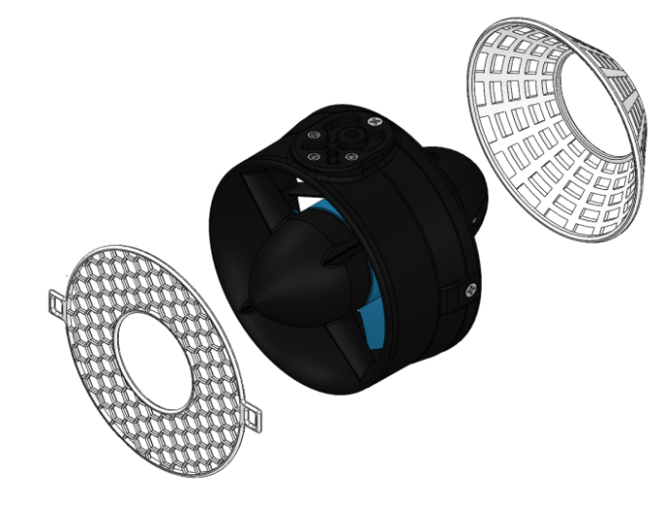

Figure12: mesh on the guard

All electronic components are fastened with epoxy and hot glue, and wires are also hot shrunk and treated with silica gel at the holes going through from inner to outer. As for the wires outside, they are also properly waterproofed with hot glue. Additionally, a function is set to cut the power source in case of possible water leaking to secure safety. And after our ROV being completed, we did a final check to make sure it fulfill all the safety requirements.

# Finances

Budget ￥23000

Cost ￥21024.64

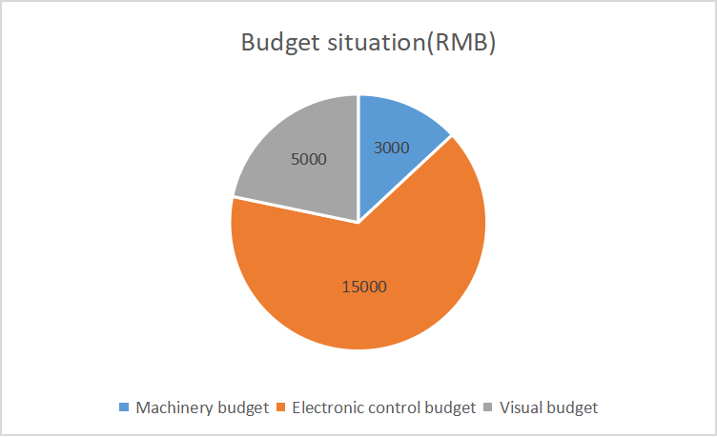

Figure13 Budget situation

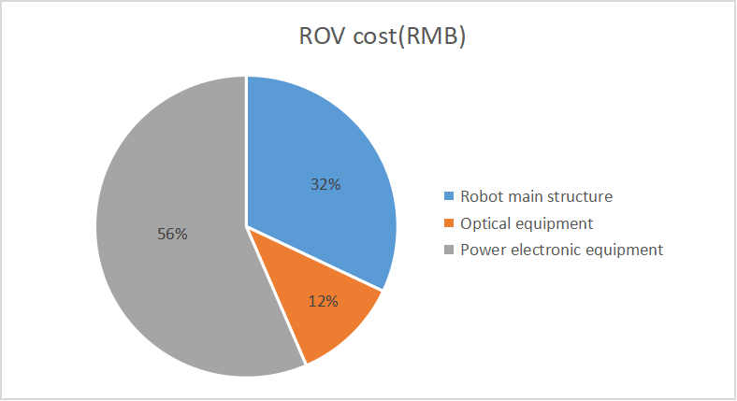

Figure14 ROV Cost

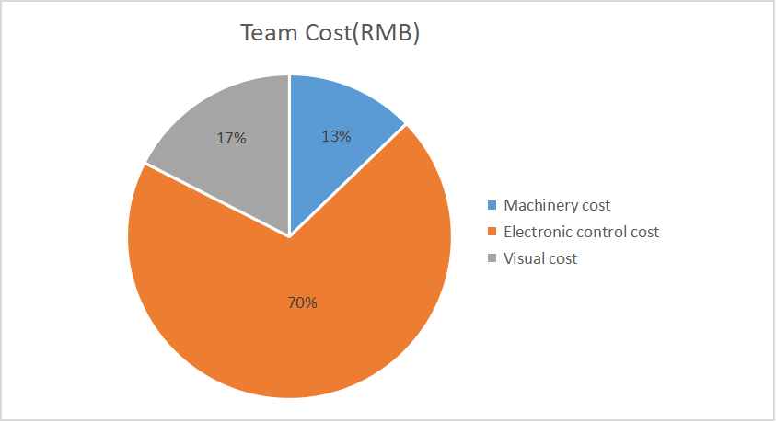

Figure15 Team Cost

# Acknowledgments

Thank the teachers, enterprises and sponsors who organized this MATE competition, the guidance of the Institute of robotics and intelligent systems of Xi'an Jiaotong University, and the venue support provided by the swimming pool of Xi'an Jiaotong University.

# References

<https://github.com/ultralytics/yolov5>

<https://github.com/eriklindernoren/PyTorch-YOLOv3>

<https://github.com/ultralytics/yolov3>

<https://github.com/cytheria43/Binocular-Stereo-Vision>

# Appendices

## Proposed Budget

|  |  |
| --- | --- |
| Machinery budget | ￥3000 |
| Electronic control budget | ￥15000 |
| Visual budget | ￥5000 |

Table2 Proposed Budget

## Cost Projection

|  |  |
| --- | --- |
| Robot main structure cost projection | ￥7000 |
| Optical equipment cost projection | ￥3000 |
| Power electronic equipment cost projection | ￥13000 |

## Table3 Cost Projection

# Operation and Construction Safety Checklist

**Operation safety checklist**

Set Up Procedure

1. Check that all company members are wearing safety glasses and closed-toed shoes
2. Check work environment and ROV for any hazards (sharp edges, untidy cables, et/slippery area)
3. Check that power supply is off
4. Inspect electrical components and connections for water proofing
5. Connect surface computer to router 6. Connect coder to router
6. Connect tether to router
7. Connect tether to power supply
8. Connect tether to ROV
9. Connect power strip containing surface laptop, TV, router, power supply to external power supply

Shut down

1. Co-pilot calls “shutting down” before powering off ROV.
2. Co-pilot shuts down surface laptop, router, TV and power supply
3. Tether manager disconnects tether from ROV.
4. Team packs all gear

**Processing safety checklist**

1. Secondary processing of glass fiber board: use hand drill to drill holes on the glass fiber board for the fixation of electronic devices. The operator must wear gloves, measure the size and position of electronic devices, and then turn on the power supply for operation after positioning. The rotation speed of hand drill cannot be set too fast, otherwise the glass fiber board may be damaged, or sliding may occur, resulting in inaccurate positioning.
2. Fixing of camera: slot on fiberglass board to fix the camera. The operator must wear gloves, select a file with appropriate size, and rub out a square slot with appropriate size after positioning.
3. Processing of control box: it is processed by laser cutting. Be familiar with the control of the machine tool. After placing the acrylic plate and setting the parameters, cover the machine tool in time, and your eyes cannot look directly at the machine tool during processing, so as to prevent the laser from damaging your vision.
4. 3D printing: we have many special parts that need 3D printing processing. First, import the model into the computer, be familiar with the basic operation of 3D printer, and start printing after placing the materials. At the beginning of printing, the operator should pay attention to whether the initial position and shape of the print are correct, and then observe it every other time.

# Electronics Troubleshooting Checklist

|  |  |  |
| --- | --- | --- |
| **Trouble** | **Cause** | **Solution** |
| The thruster stutter | the involving of foreign body | design a net fitted over the thruster |
|
| The ROV can’t moves horizontally by remote control | communication of remote control faults because of the lack of power through cable | insert a battery in the cabin |
|
| The mechanical claw over opens and closes | the mechanical claw parts are reversed | Change the parameter or assemble it |
|
| The thruster rotates wildly | communication of remote control faults because of the lack of power through cable | insert a battery in the cabin |
|
| The light of the microcontroller is off | The microcontroller has faults like short circuit or so | Connect to J-link to determine if it is damaged, and if it cannot be connected, perform hardware repairs |
|

## Table4 Electronics Troubleshooting Checklist